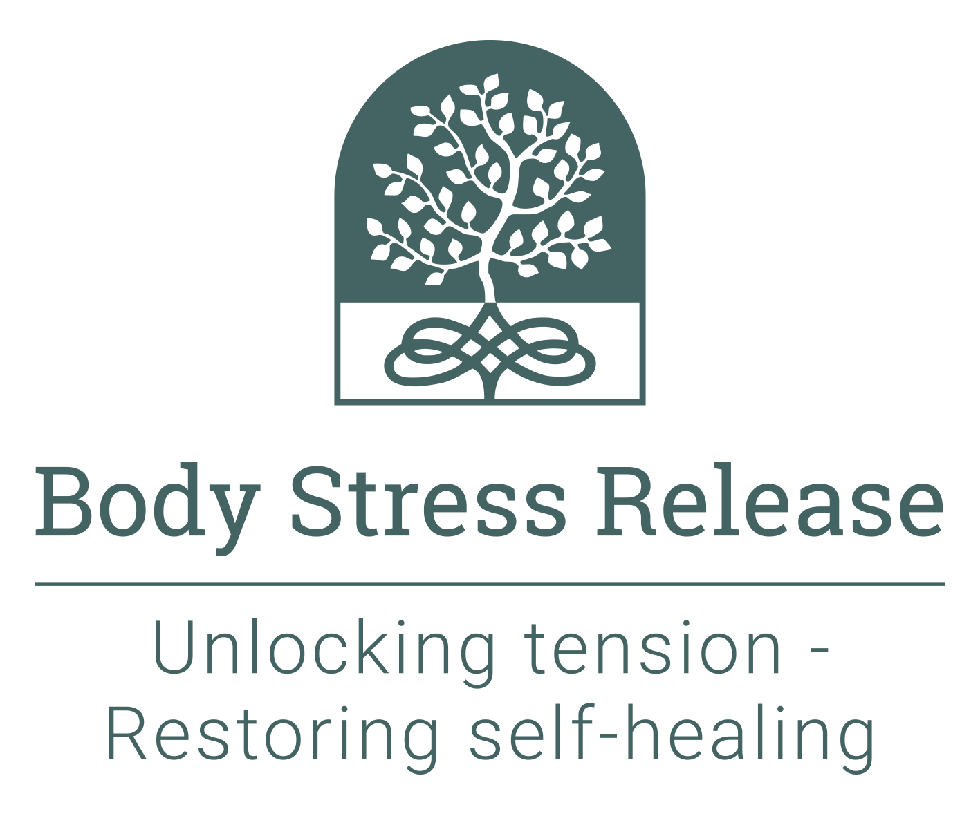
Recent photograph

Body Stress Release Academy Europe
Application Form

The Body Stress Release Academy

Established 1987

Email: studentensbsran@gmail.com

Website: www.bodystressrelease.nl

Please attach the following supporting documents:

- A short life history – minimum one page, maximum 2 pages informing us about yourself and your interests
- A recent photograph in the space provided to the right
- A scanned copy of your highest educational qualification certificates
- A scanned copy of your passport or national identity document

Title:
Surname:
First name:
Date of birth:
Residential address:
Postal address (if different):
Phone (home):
Phone (work):
Mobile phone:
Email address:
Would you prefer to use Skype or Zoom if we need to talk to you?
Skype address:
Nationality:
Marital status:
Educational qualifications: |  | Institution: | Dates attended:
Present occupation (incl. start date)
Previous occupations (incl. dates)
Personal interests:
How did you first hear about BSR?
Who is your BSR practitioner?
Explain briefly why you wish to become a practitioner:
Where do you intend to practise?
Will you practise full-time or part-time?
If part-time, why?
Do you have any physical impairments or chronic conditions? | Yes / No (please circle as appropriate) - if yes, please provide details:
Are you, or have you, ever been on any chronic medication | Yes / No (please circle as appropriate) - if yes, please provide details:
Have you ever received, or are you currently receiving, any professional assistance or support for mental health concerns? | Yes / No (please circle as appropriate) - if yes, please attach a separate explanatory statement.
Have you ever been convicted of a crime? | Yes / No (please circle as appropriate) - if yes, please attach a separate explanatory statement.

Criteria for passing the course: There are weekly Anatomy tests and several Technique Theory tests during the course, the faculty may also set additional tests if required. There is an Anatomy and a Principles Exam at the end of the first half of the course. There are final exams for Anatomy, Client Management and Technique Theory, as well as a Technique Practical Exam. The aggregate pass mark for all of these is 70%. However, anyone failing the Technique Practical Exam (getting less than 70% for it) fails the course, regardless of their aggregate mark, and will not be allowed to take part in the Apprenticeship Programme and therefore will not graduate.

Privacy Policy

The Body Stress Release Academy Europe Ltd is committed to conducting its business in accordance with all applicable Data Protection laws and regulations including the General Data Protection Regulation (“GDPR”).

This Privacy Policy relates to our use of any personal information we collect from you when you make enquiries about the Body Stress Release Practitioner Training Course (the course); apply to and / or are accepted on the course.

The personal information we collect from you
We collect basic personal details such as your name, address, email addresses, telephone numbers, and for students – details of your next of kin. We may also hold your photograph.

How we use information
We will use your information to keep you informed about matters relating to the course – such as future course dates. Your personal information may be shared with those directly involved in the administration of the Academy and with teachers. This use is in our ‘legitimate interest’. We will not share your information with third parties without your consent.

Security
We put in place reasonable security measures to protect against any unauthorised access or damage to, or disclosure or loss of, your information.

Your rights
Please let us know if your information changes as it is important that the personal information we hold about you is accurate and up to date.

We will keep your information indefinitely. For prospective students we keep your information because you may wish to resume your connection with the Academy. For students accepted on the course, we need to keep a register of all students who have trained with us should any future matters arise that may require us to refer to them. However, you can ask us to stop communicating any BSR related information to you at any time.

You have the right to request a copy of all the personal information we hold about you in a Subject Access Request. We will take all reasonable steps to confirm your identity before providing you with details of any personal information we may hold about you.

Changes to this Privacy Policy
We may amend this Privacy Policy from time to time; for example, to comply with legal requirements. If there is any significant change made to the use of your personal information in a manner different from that stated, we will seek your permission first.

Please read and sign the following statement:

I, (name) ____________________________________________________________________certify that:

- I understand that the application form must be fully complete.
- The above information provided by me is true and correct.
- I have read and understood the conditions under which students are accepted onto the training course, as stated in the prospectus.
- I understand that students are required to attend all classes, unless prevented from doing so through illness, as classes cannot be repeated.
- The Academy has the right to dismiss any student from the course if they prove unsuitable or disruptive, if their fitness to practise BSR is impaired, or if any information on the application form is found to be false. The fee is non-refundable in such a case, nor will it be refunded if the student chooses to withdraw from the course, or they are unsuccessful in completing the course.
- Applications are evaluated by the Academy faculty who have the right to decline acceptance of any individual, without giving reasons.
- Successful applicants will be required to apply for membership to the relevant association before completion of the course. The BSR Academy is a separate entity to the various BSR associations.
- A non-refundable deposit is to be paid on acceptance of a place on the course.
- Course fees are to be paid in full by 31st August.
- I have read and understood the conditions under which Body Stress Release is practised, as stated in the prospectus, and I acknowledge that if I am accepted on the course, I and my fellow students will be practising the technique on each other as an essential part of the training course.
- I have read and understood the criteria for passing the course as stated above.
- I understand and accept that as a Body Stress Release Practitioner, I am bound to comply with and abide by the International Body Stress Release Association Constitution or the BSR Constitution of the country in which I practise. A copy of the relevant Constitution will be sent to me if I am offered a place on the course.
- I understand that the legal status of Body Stress Release is not necessarily guaranteed in the area or country where I may choose to practise.
- I have read the Privacy Policy and give permission for my personal information to be stored and used by the BSR Academy and relevant BSR Association.

Signature: __________________________________ Date: ____________________________

References:

I certify the above-named to be of good and sound character.

- Name: _______________________________________________________________________

Address: _______________________________________________________________________

_______________________________________________________________________
Signature: ____________________________ Phone: ______________________________

- Name: _______________________________________________________________________

Address: _______________________________________________________________________

_______________________________________________________________________
Signature: ____________________________ Phone: ______________________________

NOTE: ALL APPLICATIONS MUST BE SIGNED - Please email signed and scanned documents (saved as one PDF document) to studentensbsran@gmail.com.

