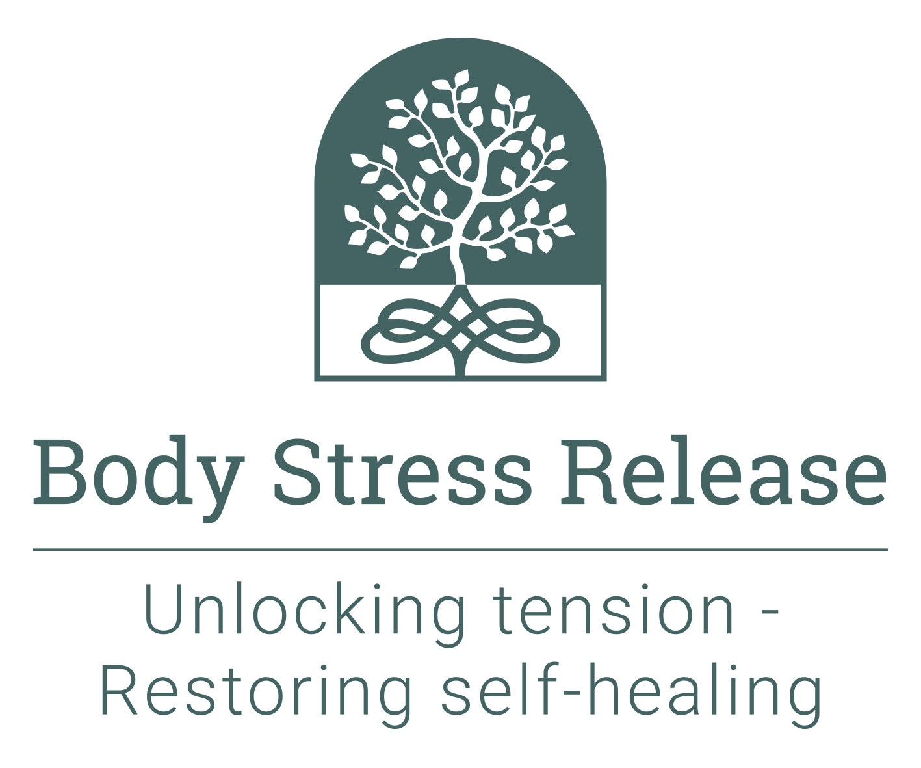
Recent photograph

Body Stress Release Academy
Application Form

The Body Stress Release Academy

Established 1987

Email: studentensbsran@gmail.com

Website: www.bodystressrelease.nl

Please attach the following supporting documents:

- A short life history – minimum one page, maximum 2 pages informing us about yourself and your interests
- A recent photograph in the space provided to the right
- A scanned copy of your highest educational qualification certificates
- A scanned copy of your passport or national identity document

Title:
Surname:
First name:
Date of birth:
Residential address:
Postal address (if different):
Phone (home):
Phone (work):
Mobile phone:
Email address:
Would you prefer to use Skype or Zoom if we need to talk to you?
Skype address:
Nationality:
Marital status:
Educational qualifications: |  | Institution: | Dates attended:
Present occupation (incl. start date)
Previous occupations (incl. dates)
Personal interests:
How did you first hear about BSR?
Who is your BSR practitioner?
Explain briefly why you wish to become a practitioner:
Where do you intend to practise?
Will you practise full-time or part-time?
If part-time, why?
Do you have any physical impairments or chronic conditions? | Yes / No (please circle as appropriate) - if yes, please provide details:
Are you, or have you, ever been on any chronic medication? | Yes / No (please circle as appropriate) - if yes, please provide details:
Have you ever received, or are you currently receiving, any professional assistance or support for mental health concerns? | Yes / No (please circle as appropriate) - if yes, please attach a separate explanatory statement.
Have you ever been convicted of a crime? | Yes / No (please circle as appropriate) - if yes, please attach a separate explanatory statement.
Criteria for passing the course: There are weekly Anatomy tests and several Technique Theory tests during the course, the faculty may also set additional tests if required. There is an Anatomy and a Principles Exam at the end of the first half of the course. There are final exams for Anatomy, Client Management and Technique Theory, as well as a Technique Practical Exam. The aggregate pass mark for all of these is 70%. However, anyone failing the Technique Practical Exam (getting less than 70% for it) fails the course, regardless of their aggregate mark, and will not be allowed to take part in the Apprenticeship Programme and therefore will not graduate.

Privacy Policy

The Protection of Personal Information ACT – the POPI Act - became law in South Africa from 1 July 2021. By completing this application form and forwarding it, together with the supporting documents, to the Body Stress Release Academy (the Academy) you agree that the Academy as well as the International Body Stress Release Association and its affiliated National Body Stress Release Associations may store the information and use it as follows:

- If you are accepted on the course, the information stored and used will include the content of this application form, the supporting documents you provide, any additional application form for membership of a BSR Association, any correspondence or communication you have with the Academy and any records of fee payments or other payments.
- If you are not accepted on the course the information is stored for up to five years after which it will be destroyed unless you request that it be destroyed immediately on being notified that you were not allocated a place on the course.
- The information is stored on computer hard drives and in the cloud.
- The information is treated in strictest confidence and only the Academy Faculty committee of the BSR Association concerned will have access to it.
- The information is used to assess your application to do the BSR training course.
- If you are selected to do the BSR training course and, on graduating, become a member of one of the BSR Associations, the information will be stored for the duration of your membership of the Association and for up to five years after. Please note that the BSR Academy and the BSR Associations are separate entities.

Your rights under the POPI Act include the following:

- To have access to your personal information that is kept by the Academy and relevant BSR Association;
- To be informed if someone else is collecting or has accessed your personal information;
- To have any incorrect or obsolete information corrected or destroyed; and
- To object to any unauthorised use (or “processing”) of personal information.

Additional terms and conditions may be viewed on the website: www.bodystressrelease.com. You are welcome to contact the Academy to discuss any aspect of this.

Please read and sign the following statement:

I, (name) ____________________________________________________________________certify that:

- I understand that the application form must be fully complete.
- The above information provided by me is true and correct.
- I have read and understood the conditions under which students are accepted onto the training course, as stated in the prospectus.
- I understand that students are required to attend all classes, unless prevented from doing so through illness, as classes cannot be repeated.
- The Academy has the right to dismiss any student from the course if they prove unsuitable or disruptive, if their fitness to practise BSR is impaired, or if any information on the application form is found to be false. The fee is non-refundable in such a case, nor will it be refunded if the student chooses to withdraw from the course, or they are unsuccessful in completing the course.
- Applications are evaluated by the Academy faculty who have the right to decline acceptance of any individual, without giving reasons.
- Successful applicants will be required to apply for membership to the relevant association before completion of the course. The BSR Academy is a separate entity to the various BSR associations.
- A non-refundable deposit is to be paid on acceptance of a place on the course.
- For the Body Stress Release Academy South Africa, fees are to be paid in full by 31st March. For the Body Stress Release Academy Europe, course fees are to be paid in full by 31st August.
- I have read and understood the conditions under which Body Stress Release is practised, as stated in the prospectus, and I acknowledge that if I am accepted on the course, I and my fellow students will be practising the technique on each other as an essential part of the training course.
- I have read and understood the criteria for passing the course as stated above.
- I understand and accept that as a Body Stress Release Practitioner, I am bound to comply with and abide by the International Body Stress Release Association Constitution and the BSR Constitution of the country in which I practise. A copy of the relevant Constitution will be sent to me if I am offered a place on the course.
- I understand that the legal status of Body Stress Release is not necessarily guaranteed in the area or country where I may choose to practise.
- I have read the Privacy Policy and give permission for my personal information to be stored and used by the BSR Academy and relevant BSR Association.

Signature: __________________________________ Date: ____________________________

References:

I certify the above-named to be of good and sound character.

1. Name: _______________________________________________________________________

Address: _______________________________________________________________________

_______________________________________________________________________

Phone: _______________________________________________________________________

Signature: ____________________________

2. Name: _______________________________________________________________________

Address: _______________________________________________________________________

_______________________________________________________________________

Phone: _______________________________________________________________________

Signature: ____________________________

NOTE: ALL APPLICATIONS MUST BE SIGNED - Please email signed and scanned documents (saved as one PDF document) to studentensbsran@gmail.com.

